5th International Symposium on Larger Asian Rivers:
Climate Change, River Flow and Hydropower Development
(2nd circular)

November 7-8, 2011, Nanjing, Jiangsu Province, China

General Purposes:

Climate change and uneven spatial and temporal distribution of water resources (e.g. river flow) in larger Asian River basins are issues of considerable concern (Figure 1). Recent research has revealed that increasing temperatures in some of the larger Asian river basins have intensified the water cycle and aggravated water related natural hazards. Meanwhile, human interventions through regulating temporal and spatial distribution of water resources with water transfer schemes and the constructions of large reservoirs and dams for hydropower generation have been increased.

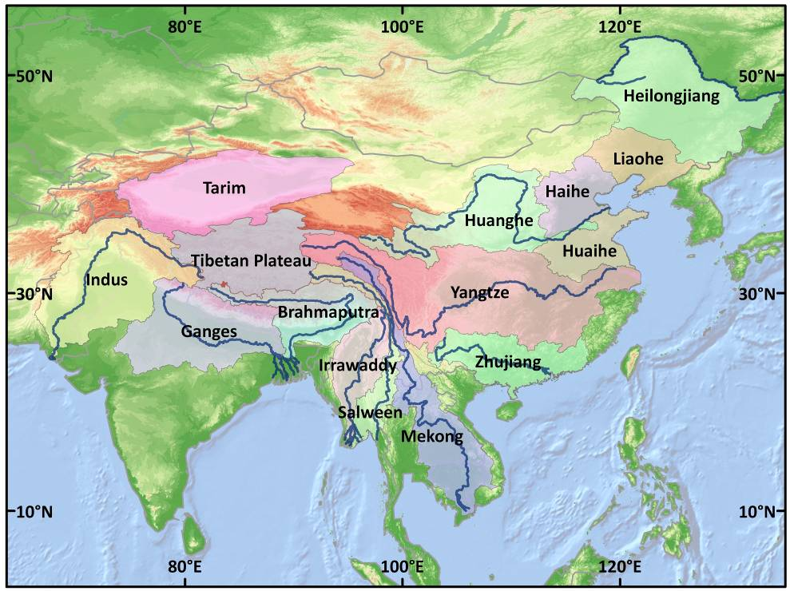
Figure 1 Larger Asian Rivers

Some of the larger Asian river basins have recently experienced catastrophic hydro-meteorological events such as the extreme flooding in the Indus Basin in Pakistan in summer 2010, the extreme drought in southwest and northeast China in winter 2010 and along the Yangtze River in spring 2011. Climate change was partially blamed for these extreme events, to which human activities like land use changes, watershed management and dam constructions also contributed. Impacts on the hydrological system and water resources are projected to be more severe in the future, due to increased frequency and intensity of floods and droughts, intensified erosion and sedimentation, expanding water scarcity, reductions in glaciers, sea ice and snow cover, damages to water quality, and pollution of entire ecosystems.

More environmental changes in larger Asian river basins have been foreseen as a result of the rapid economic and hydropower development. This symposium will provide an opportunity for international academics, scholars, engineers and decision makers to exchange the latest research in these fields. During a field excursion, the participants of this symposium will have an opportunity to experience the changes and developments in climatic and hydrologic conditions, and water projects transferring water from the Yangtze to Beijing.

This 5th International Symposium on Larger Asian Rivers will be jointly organized with the National Climate Centre (NCC), Nanjing University of Information Sciences and Technology (NUIST), National University of Singapore (NUS), Nanjing Institute of Geography and Limnology (Niglas), CAS, and with funding from the German Embassy (Climate Fund).

The topics of this symposium include, but are not limited to:

- Current and future climate change in larger Asian river basins
- Impact of climate change on river flow and sediment discharge
- Effects of hydropower development on the hydro-climatic and ecological environments of watersheds
- Interactions of climate change with human activities (e.g. land use, reservoirs and dam construction, water diversion, and sand mining) and their impacts on climatic and hydrologic processes

Invited speakers and participants will provide case studies drawn from larger Asian rivers such as Huanghe (Yellow River), Changjiang (Yangtze River), Zhujiang (Pearl River), Lancang (Mekong River), Red River, Chao Phraya River, Irrawaddy River, Salween River, Ganges River, and Brahmaputra River. In addition, research on other larger Asian rivers can also be presented and reported in this symposium.

A 5th special issue on Larger Asian Rivers in the international peer-reviewed journal Quaternary International (2010 impact factor >1.7) will be published after the symposium. Four special issues on Larger Asian Rivers out of such symposiums have already been published in this journal.
Funding Organizations:

National Climate Centre (NCC)
National University of Singapore (NUS)
State Key Laboratory of Lake and Environment, Nanjing Institute of Geography and Limnology, CAS
German Embassy

Organizers:

Prof. Dr. Qiu Xinfa
Nanjing University of Information Sciences and Technology (NUIST)
Email: 000367@nuist.edu.cn

Prof. Jiang Tong
National Climate Centre (NCC)
China Meteorological Administration (CMA)
46, Zhongguancun Nandajie
Haidian, Beijing 100 081, PR China
Office: 0086 10 5899 5881
Mobile: 0086 138 110 52930
Email: jiangtong@cma.gov.cn

Dr. Lu Xi Xi
Department of Geography
National University of Singapore
Singapore 119260
Tel.: 65-65166135
Fax: 65-67773091
Email: geoluxx@nus.edu.sg

Prof. Dr. Xue Bin
State Key Laboratory of Lake and Environment
Nanjing Institute of Geography and Limnology (NIGLAS)
Chinese Academy of Sciences
73 East Beijing Road, Nanjing 210008
China
Email: bxue@niglas.ac.cn

Date and Venue:

On November 7-8, 2011, the symposium will be held in the Nanjing University of Information Sciences and Technology (NUIST) University Hotel in Nanjing, the capital city of Jiangsu Province, to which there are direct flights from major Asian cities (e.g. Beijing, Shanghai, Hong Kong, Singapore).

Address: Nanjing University of Information Sciences and Technology (NUIST)
University Hotel
219, Ningliu Lu
Pukou, Nanjing, PR China

Symposium Program:

5/6. November: Arrival and Registration of Participants
6. November: Pre Conference trip to Yangzhou
7. – 8. November: Presentations of Symposium
9. November: Post Conference trip to Yangzhou
10. November: Departure of Participants

Registration and Costs:

Around 50 participants are expected to join this symposium. The participants are required to cover their own flights and accommodation in the NUIST University Hotel (around 200 RMB/day) costs. The registration fee is free. The costs for the pre-conference or the post-conference trip (optional) to Yangzhou will be covered by the organizers. The German Embassy (Climate Fund) is funding the travel and accommodation costs for 20 students to participate in the symposium.

If an official invitation letter for visa application is needed, please send an e-mail with your registration form to Prof. Jiang Tong as soon as possible.

Abstract:

Participants are expected to contribute to the symposium with a presentation on a related topic (in consultation with the organizers). Please e-mail your abstract together with your registration form to the symposium secretaries by End of October, 2011.

Symposium Secretaries:

Mr. Li Xiucang / Mr. Thomas Fischer
National Climate Centre (NCC), China Meteorological Administration (CMA)
46, Zhongguancun Nandajie, Haidian, Beijing 100 081, PR China
Email: lixiucang@163.com Mobile: 0086 15010639610 (Chinese/English)
Email: tom.fischer8@gmx.de Mobile: 0086 15810520398 (German/English)

Local Secretaries:

Ms. Wang Yanjun
Nanjing University of Information Sciences and Technology (NUIST)
Tel.: 13913981575
Email: yjwang78@163.com
Registration Form:

5th International Symposium on Larger Asian Rivers:
Climate Change, River Flow and Hydropower Development

November 7-8, 2011, Nanjing, Jiangsu Province, China

Name: | (Surname) (Given Name)
Passport Number:
Affiliation:
Address:
Phone/Fax:
E-mail:
Title of Presentation:
Remarks:
Participation in Field Excursion: (yes/no)

Please send this registration form by End of October, 2011 to:

Mr. Li Xiucang / Mr. Thomas Fischer
National Climate Centre (NCC), China Meteorological Administration (CMA)
46, Zhongguancun Nandajie, Haidian, Beijing 100 081, PR China
Email: lixiucang@163.com Mobile: 0086 15010639610 (Chinese/English)
Email: tom.fischer8@gmx.de Mobile: 0086 15810520398 (German/English)

5th Special Issue on Larger Asian Rivers:
Climate Change, River Flow and Hydropower Development
CALL FOR PAPER
Climate change and uneven spatial and temporal distribution of water resources (e.g. river flow) in larger Asian River basins are issues of considerable concern. Recent research has revealed that increasing temperatures in some of the larger Asian river basins have intensified the water cycle and aggravated water related natural hazards. Meanwhile, human interventions through regulating temporal and spatial distribution of water resources with water transfer schemes and the construction of large reservoirs and dams for hydropower generation have been increased. For example, the project of a long distance South-North water transfer scheme and the plan to duplicate hydropower generation through dams by 2020 has been envisaged in China. More environmental changes in larger Asian river basins have been foreseen as a result of the rapid economic and hydropower development.

The topics of this special issue shall include, but are not limited to:

- Current and future climate change in larger Asian river basins
- Impact of climate change on river flow and sediment discharge
- Effects of hydropower development on hydro-climatic and ecological environments of watersheds
- Interactions of climate change with human activities (e.g. land use, reservoirs and dam construction, water diversion, and sand mining) and their impacts on climatic and hydrologic processes

New research and findings in the aforementioned topics will be presented at the 5th International Symposium on Larger Asian Rivers, in Nanjing, Jiangsu Province, China, in November 2011. The presented research in this symposium will be published in the 5th special issue on larger Asian rivers. With this Call of Paper, we invite all related and interested scholars to submit their research papers and to participate and present their findings at the 5th international Symposium. The topics of the papers should focus on research and case studies drawn from larger Asian rivers such as Huanghe (Yellow River), Changjiang (Yangtze River), Zhujiang (Pearl River), Honghe (Red River), Lancang (Mekong River), Chao Phraya River, Irrawaddy River, Salween River, Ganges River, and Brahmaputra River. In addition, research on other larger Asian rivers can also be submitted.

The 5th Special Issue on Larger Asian Rivers will be published in the international peer-reviewed journal Quaternary International (2010 impact factor >1.7) in 2012. Please submit your paper to Quaternary International by the end of December, 2011, to ensure its publication in the 5th special issue.

Guest editors:

Prof. Dr. Jiang Tong
National Climate Centre (NCC)
China Meteorological Administration (CMA)
Email: jiangtong@cma.gov.cn

Prof. Dr. Lu Xi Xi
Department of Geography
National University of Singapore (NUS)
Email: geoluxx@nus.edu.sg

