Supplementary Material
for
Simultaneous Determination of Mono- and Disubstituted Polyfluoroalkyl Phosphates in Drinking Water by Liquid Chromatography-Electrospray Tandem Mass Spectrometry
Huanhuan DING^{1, 2}, Hui PENG¹, Min YANG², and Jianying HU¹*
¹MOE Laboratory for Earth Surface Process, College of Urban and Environmental Sciences, Peking University, Beijing 100871, China
²State Key Lab of Environmental Aquatic Chemistry, Research Center for Eco-Environmental Sciences, Chinese Academy of Sciences, Beijing 100085, China;

- Synthesis of mixed PAPs
The synthesis procedures of 4:2/6:2 diPAP, 6:2/8:2 diPAP, and 8:2/10:2 diPAP were similar to the method for synthesizing diPAPs (y=x) as described in previous paper [1].. To establish anhydrous conditions, triethylamine (TEA) was dried by distillation under nitrogen, and tetrahydrofuran (THF) was dried by reflux over sodium with benzophenone as an indicator. Under nitrogen atmosphere at -78°C, 3 mol equivalent of dry TEA in 10 mL of dry THF was added to 1 mole equivalent of x:2 FTOH and 1 mol equivalent of y:2 FTOH in 30 ml of dry THF over 10 min, and then 1 mol equivalent of phosphorus oxychloride in 10 mL of dry THF was added to the above reaction mixture over 1 h. After the reaction mixture was allowed to warm to room temperature within 1-2 h, 50 mL of distilled deionized water was added over 1 h.
The crude products were passed through the conditioned WAX cartridges at a flow rate of 1~2 drops/s, and the cartridges were then dried under a flow of nitrogen. After eluting the FTOH analytes from WAX cartridges using 6 ml of methanol, 6 mL of methanol containing 0.5% NH₄OH was used to elute monosubstituted polyfluoroalkyl phosphates and disubstituted polyfluoroalkyl phosphates. The methanol containing 0.5% NH₄OH fractions were dried under a gentle nitrogen stream and redissolved with 0.5 mL of methanol. 5 mL of a 0.25 M sodium carbonate buffer and 5mL of a 0.5 M tetrabutyl ammonium hydrogen sulfate (TBAS) solution were added to the 0.5 mL of methanol. The products were then extracted with three 20 mL aliquots of methyl tert-butyl ether (MTBE) which were combined, and dried under nitrogen. Thus, the disubstituted polyfluoroalkyl phosphates products were obtained.
We used HPLC fractionation method to isolate PAPs from impurities. The fractions were collected at 5-min interval from 0 min to 45 min for monoPAPs, 40 min to 80 min for diPAPs (y=x), and then analyzed the PAPs in each fraction by UPLC-MS/MS after dilution. Thus, the fractions contained target PAPs were collected, combined and evaporated to get purified PAPs. In detail, the HPLC fractionation was conducted by a Waters HR C18 column (6 μm; 19 mm × 300 mm). The column was maintained at 40 °C, and a flow rate and the injection volume were 6 mL/min and 100 μL, respectively. Methanol (A) and ultrapure water containing 0.1% NH₄OH (B) were used as mobile phases. 20% A was increased to 100% in 100 min and kept for 5 min, followed by a decrease to initial conditions of 20% A and held for 20 min to allow for equilibration.
Since it’s difficult to isolate mixed diPAPs (y=x+2) from two corresponding y=x diPAPs, The purification method for mixed diPAPs based on HPLC fractionation was similar to other PAPs with some modification, we collected the fractions at 2 min interval from 14-40 min for 4:2/6:2 diPAPs, from 20-60 min for 6:2/8:2 diPAPs, 40-90 min for 8:2/10:2 diPAPs.
2. Typical 19F-NMR spectra of some PAPs
(a) 4:2 monoPAP:
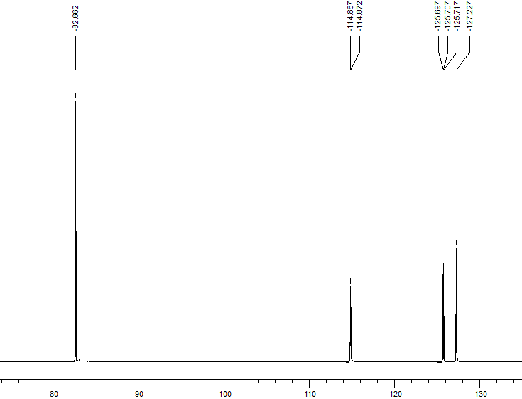
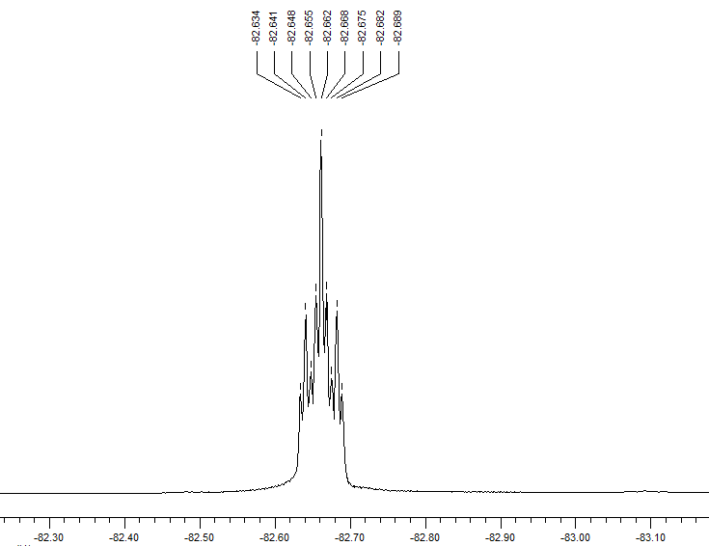
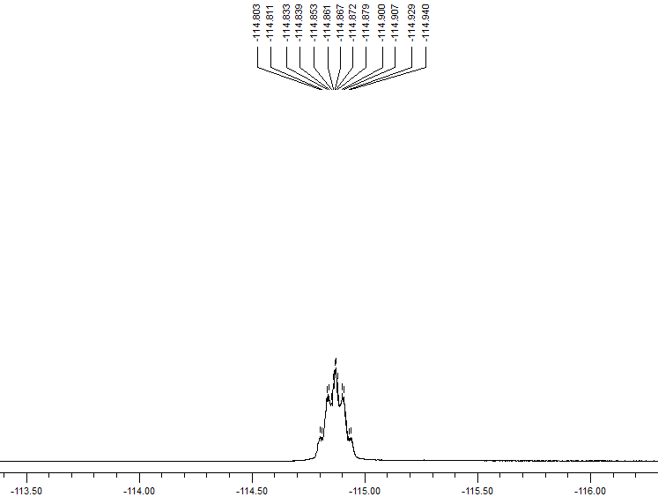
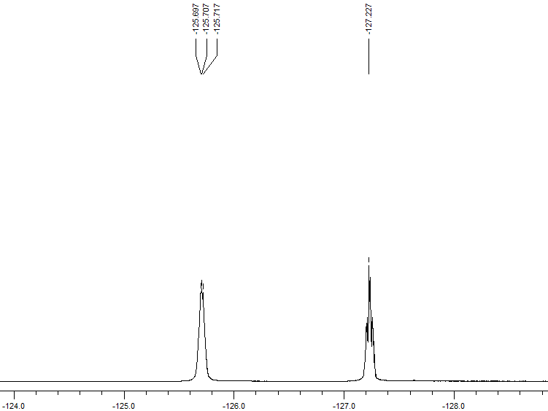

(b) 6:2 monoPAP
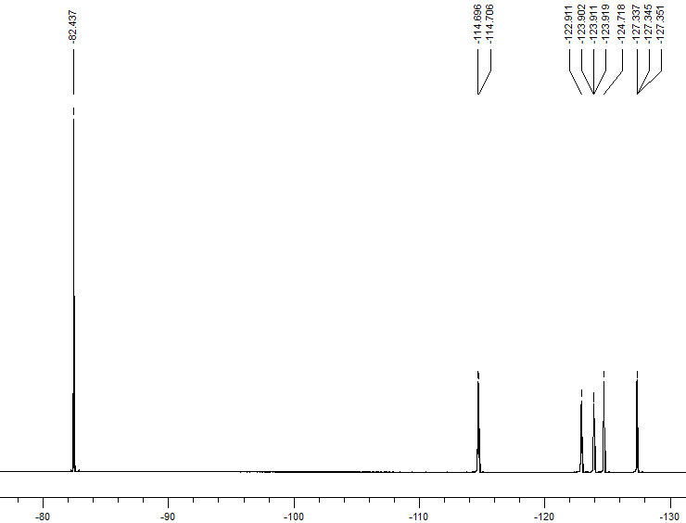
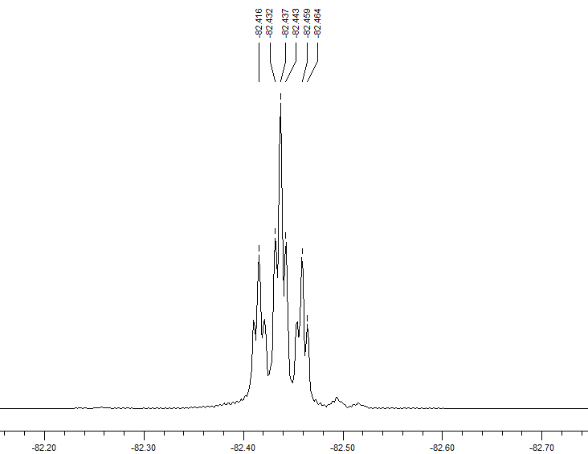
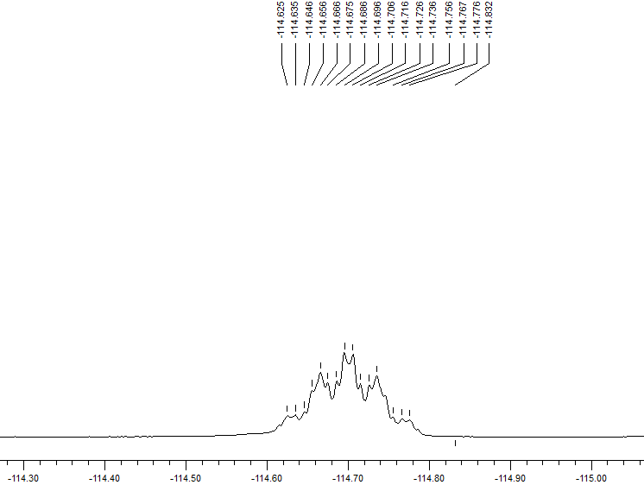
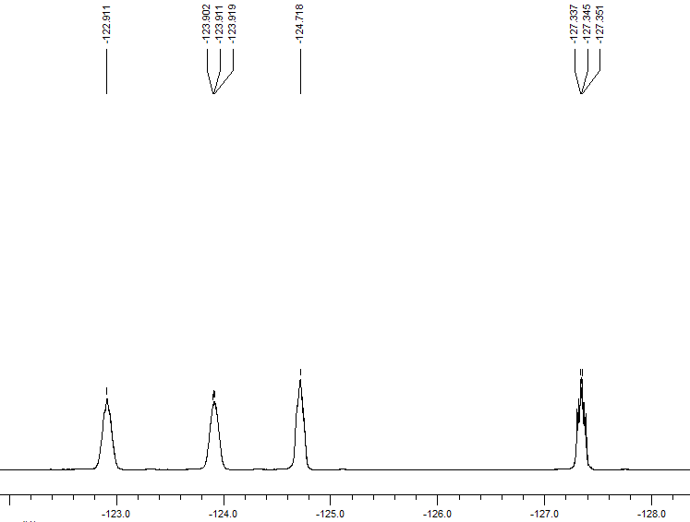

(c) 8:2 monoPAP:
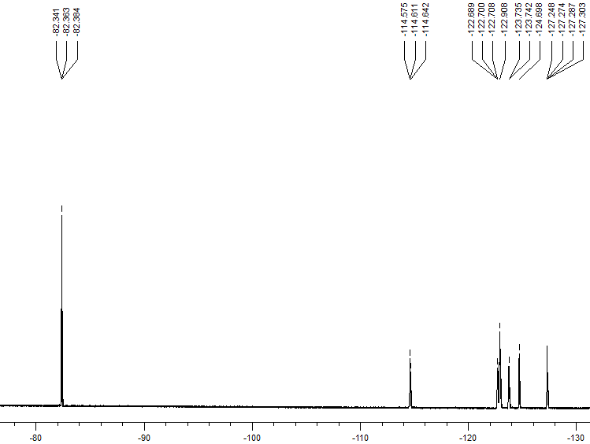
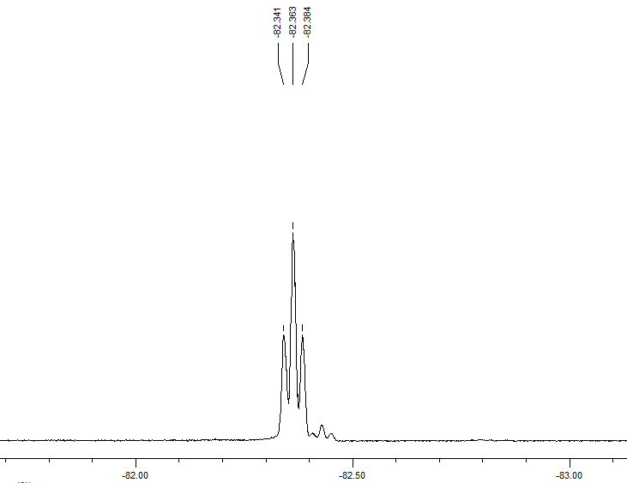
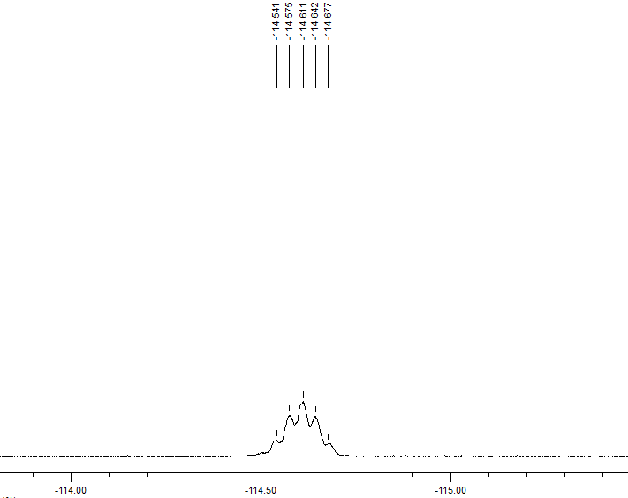
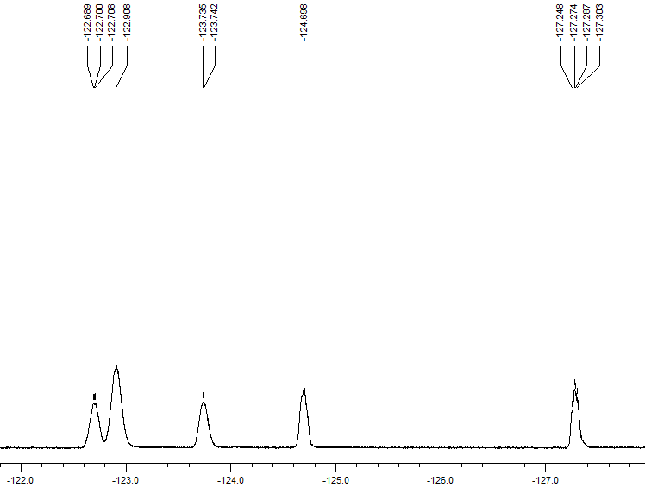
(d) 4:2 diPAP
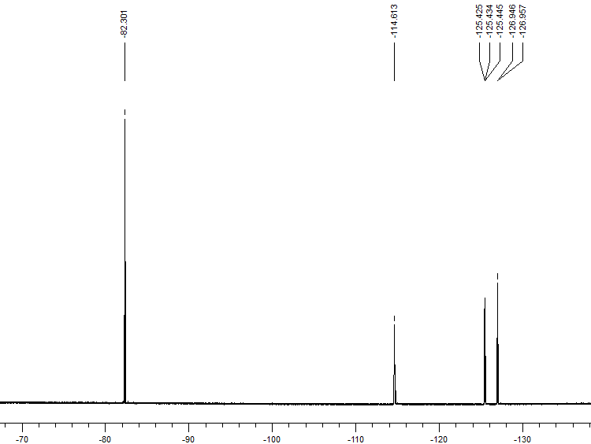
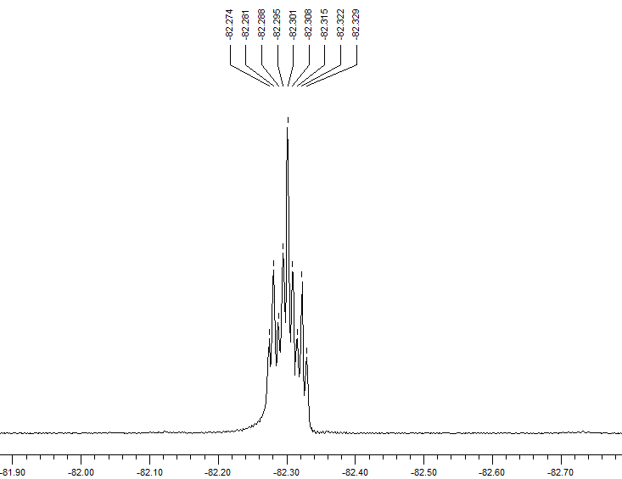
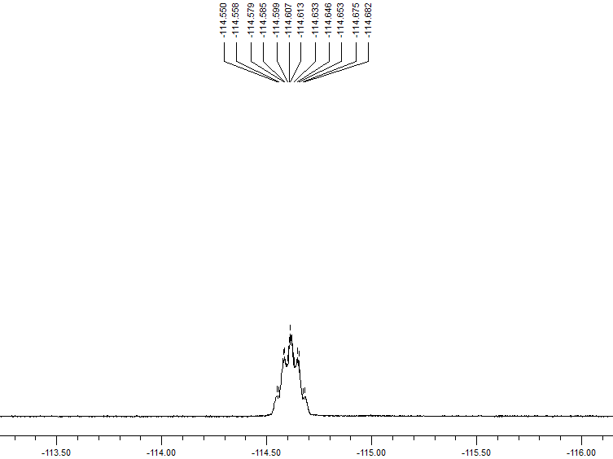
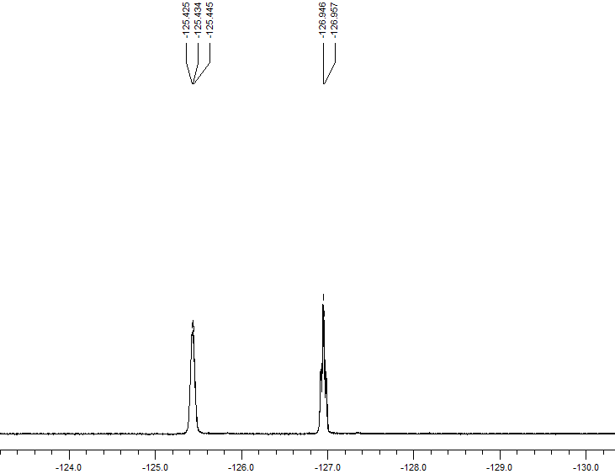
(e) 4:2/6:2 diPAP:

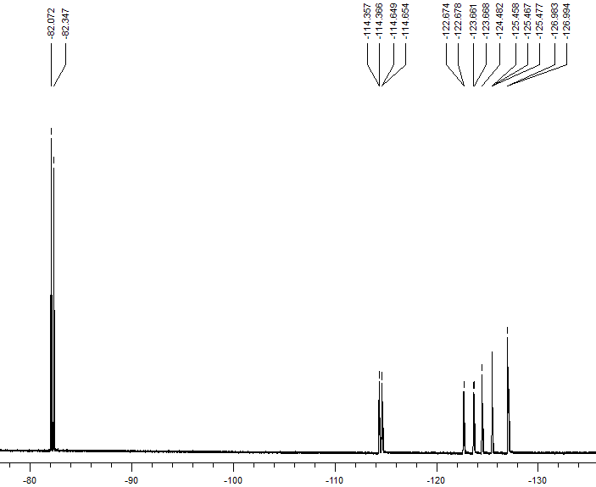
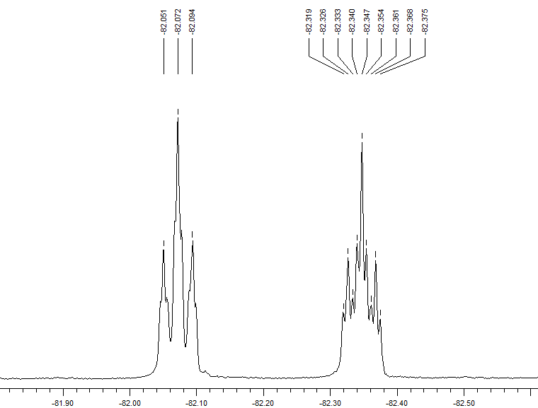
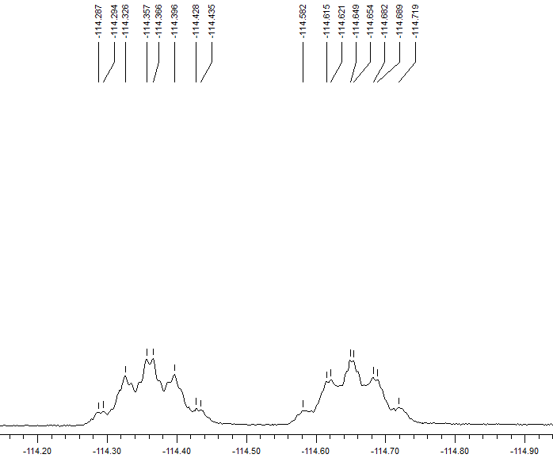
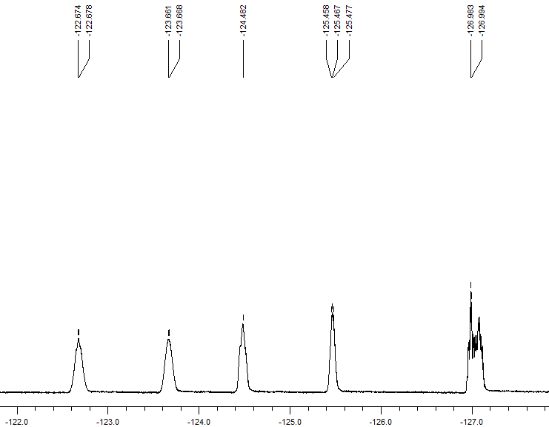
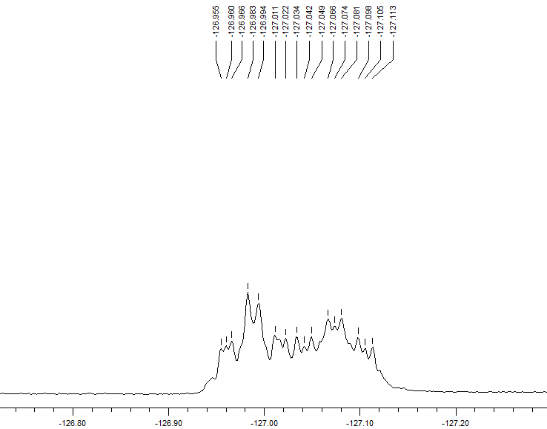

Fig. S1. Typical 19F-NMR spectra of some PAPs which were synthesized in this study.
References
[1]. J.C. D’eon, S.A. Mabury, Environ. Sci. Technol. 41 (2007) 4799.

