Supplementary Material
for
Transformation of Tetracycline during Chloramination: Kinetics, Products and Pathways
Yi WAN, Ai JIA, Zhou ZHU, and Jianying HU*
MOE Laboratory for Earth Surface Processes, College of Urban and Environmental Sciences, Peking University, Beijing, 100871 China

Figures 10
Tables 0

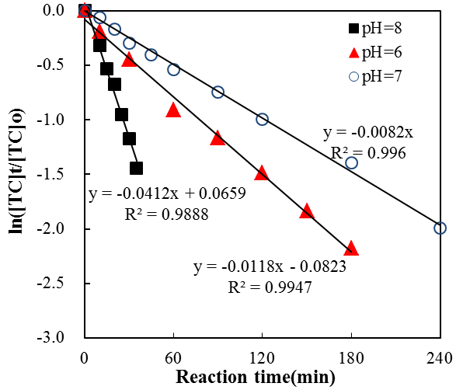

Figure S1. Pseudo-first-order kinetic plot of tetracycline chloramination at 25 °C, [CC]₀ = 1.46-1.62 mg/L and three pH levels. Symbols represent measured data, and the straight line is the linear regression.

100
m/z
100
m/z
445
410
446
269
241
251
337
321
291
297
410
349
365
392
411
200
230
260
290
320
350
380
410
440
470
500
0
%
0
100
%
(b)
(a)
445
410
446
269
241
251
337
321
291
297
410
349
365
392
411
200
230
260
290
320
350
380
410
440
470
500
200
230
260
290
320
350
380
410
440
470
500
0
%
0
100
%
(b)
(a)
[M+H]⁺
[M+H-H₂O-NH₃]⁺
428
[M+H-NH₃]⁺
RT: 10.90 min

Figure S2. LC-MS mass spectra of TC before chloramination. Cone voltage: (a) 30V; (b) 80 V.

Figure S3. LC-MS mass spectra of product A. Cone voltage: (a) 30V; (b) 80 V.

Figure S4. LC-MS mass spectra of product D. Cone voltage: (a) 30V; (b) 90 V.

Figure S5. LC-MS mass spectra of product K. Cone voltage: (a) 30V; (b) 60 V; (c): 80 V.

Figure S6. LC-MS mass spectra of product F. Cone voltage: (a) 30V; (b) 60 V.

Figure S7. LC-MS mass spectra of product B. Cone voltage: (a) 30V; (b) 80 V.

(c)
(a)
(d)
(b)
(e)

Figure S8. LC-MS mass spectra of product C (a), I (b), and G (c) at cone voltage of 60 V; (d) and (e) were mass spectra of product C and I, respectively at cone voltage of 80 V. No new fragmentation ions were observed for product G at cone voltage of 80 V.

Figure S9. Proposed structures and reaction pathways among products C, G, I and TC.

Figure S10. LC-MS mass spectra of product J. Cone voltage: (a) 30V; (b) 50 V.

