Supporting Information
For
Molecular and physiological characterization of fluoroquinolone resistance and uropathogenicity among Escherichia coli Isolates isolated from Wenyu River, China
Jianxian SUN, Jianying HU*, Hui PENG, Jiachen SHI, and Zhaomin DONG
Laboratory for Earth Surface Processes, College of Urban a- Environmental Sciences, Peking University, Beijing 100871, China

Table S1. PCR Primers Targeting Quinolone Resistance Determining Regions (QRDRs) of gyrA and parC.
Primer | Class targeted | 5’ to 3’ Sequence PCR | Amplicon size (bp) | Ref
gyrA-FW  gyrA-RV | gyrA | ACGTACTAGGCAATGACTGG  AGAAGTCGCCGTCGATAGAAC | 189 | Everett et al., 1996
parC-FW  parC-RV | parC | TGTATGCGATGTCTGAACTG  CTCAATAGCAGCTCGGAATA | 264 | Everett et al., 1996

Table S2. PCR Primers Targeting Six Virulence Factors.
Primer | Class targeted | 5’ to 3’ Sequence PCR | Amplicon size (bp) | Ref
pap1-FW  pap1-RV | pap1 | GAC GGC TGT ACT GCA GGG TGT GGC G  ATA TCC TTT CTG CAG GGA TGC AAT A | 328 | Yamamoto et al., 1995
pap2-FW  pap2-RV | pap2 | GCA ACA GCA ACG CTG GTT GCA TCA T  AGA GAG AGC CAC TCT TAT ACG GAC A | 336 | Yamamoto et al., 1995
sfa-FW  sfa-RV | sfa | CTC CGG AGA ACT GGG TGC ATC TTA C  CGG AGG AGT AAT TAC AAA CCT GGC A | 410 | Yamamoto et al., 1995
afaI-FW  afaI-RV | afaI | GCT GGG CAG CAA ACT GAT AAC TCT C  CAT CAA GCT GTT TGT TCG TCC GCC G | 498 | Yamamoto et al., 1995
aer-FW  aer-RV | aer | TAC CGG ATT GTC ATA TGC AGA CCG  AAT ATC TTC CTC CAG TCC GGA GAA G | 602 | Yamamoto et al., 1995
cnfI-FW  cnfI-RV | cnfI | AAG ATG GAG TTT CCT ATG CAG GAG  CAT TCA GAG TCC TGC CCT CAT TAT T | 750 | Yamamoto et al., 1995
hly-FW  hly-RV | hly | AAC AAG GAT AAG CAC TGT TCT GGC T  ACC ATA TAA GCG GTC ATT CCC GTC A | 1177 | Yamamoto et al., 1995

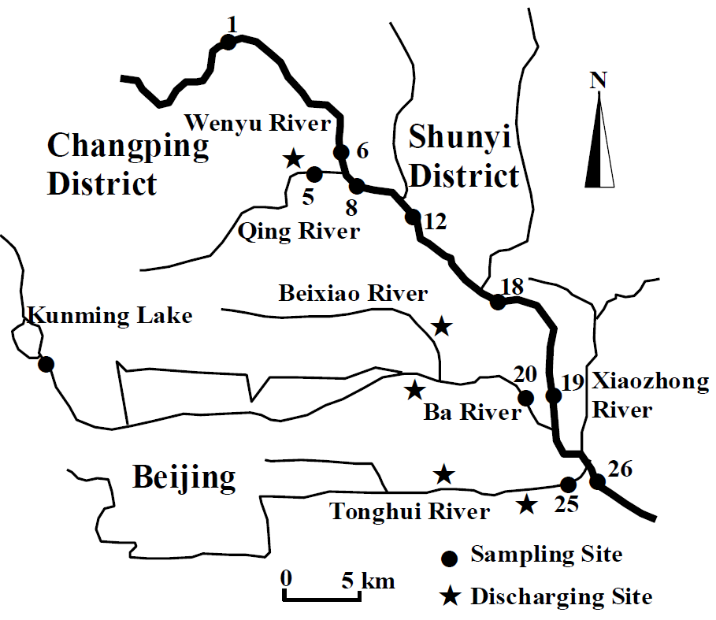
Fig. S1. Map of sampling points in the Wenyu River Basin.
Fig. S2. Comparison of nucleotide and deduced amino acid sequences of gyrA subunits. The numbers on the left correspond the nucleotide positions and the amino acid residues. MICs were shown in the brackets (μg/mL).
82
82
81
81
Fig. S3. Comparison of nucleotide and deduced amino acid sequences of parC subunits. The numbers on the left correspond the nucleotide positions and the amino acid residues. MICs were shown in the brackets (μg/mL).
References
Everett, M.J., Jin, Y.F., Ricci, V., Piddock, L., 1996. Contributions of Individual Mechanisms to Fluoroquinolone Resistance in 36 Escherichia coli Strains Isolated from Humans and Animals. Antimicrobial Agents And Chemotherapy 40, 2380-2386.
Yamamoto, S., Terai, A., Yuri, K., Kurazono, H., Taeda, Y., Yoshida, O., 1995. Detection of Urovirulence Factors in Escherichia coli by Multiplex Polymerase Chain Reaction. Fems Immunology And Medical Microbiology 12, 85-90.

